AREA AND PERIMETER
Pearson Edexcel - Monday 8 June 2020 - Paper 3 (Calculator) Foundation Tier

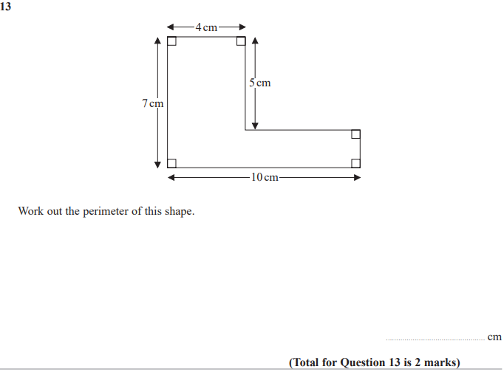

Pearson Edexcel - Tuesday 11 June 2019 - Paper 3 (Calculator) Foundation Tier

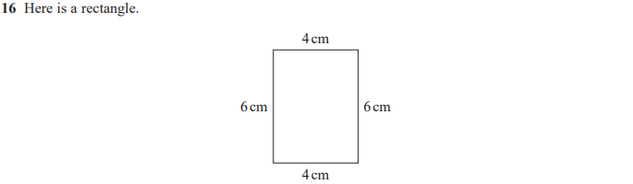
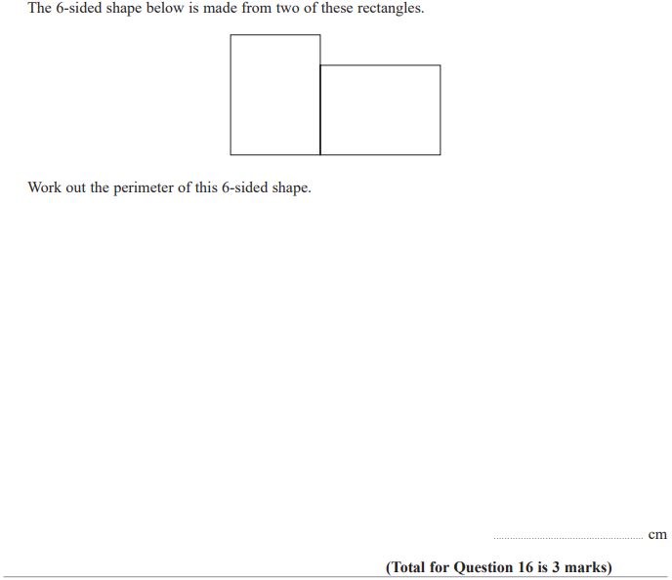

Pearson Edexcel - Thursday 8 November 2018 - Paper 2 (Calculator) Foundation Tier

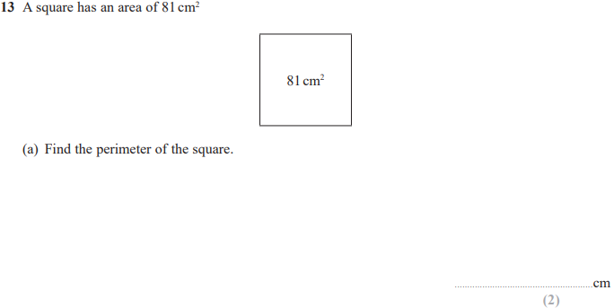
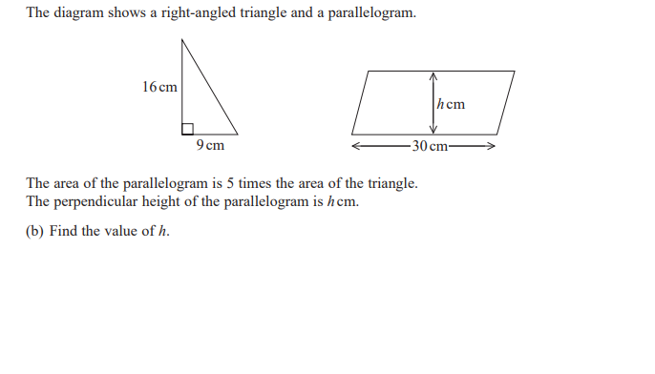

Pearson Edexcel - Tuesday 12 June 2018 - Paper 3 (Calculator) Foundation Tier

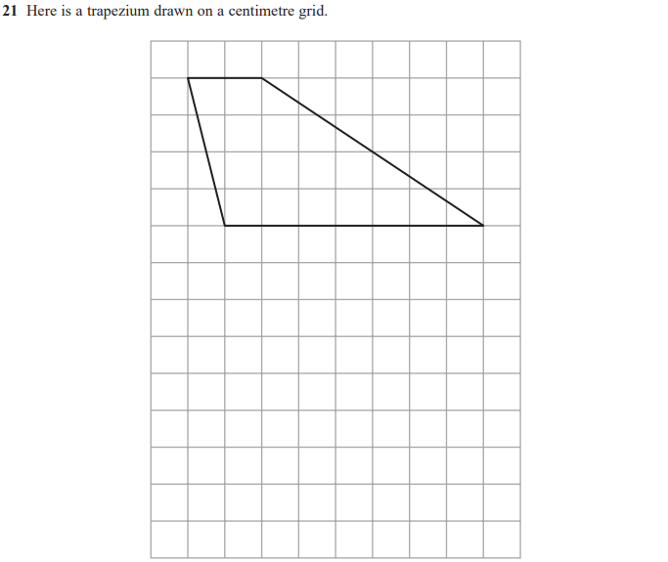
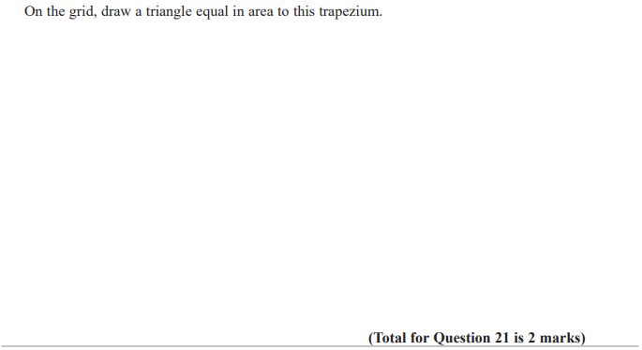

Pearson Edexcel - Thursday 2 November 2017 - Paper 1 (Non-Calculator) Foundation Tier

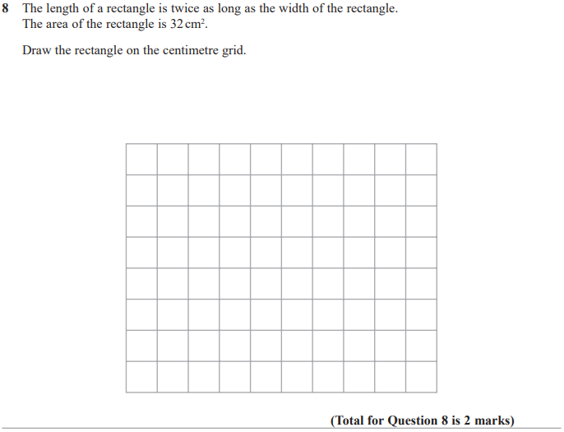

Pearson Edexcel - Monday 6 November 2017 - Paper 2 (Calculator) Foundation Tier

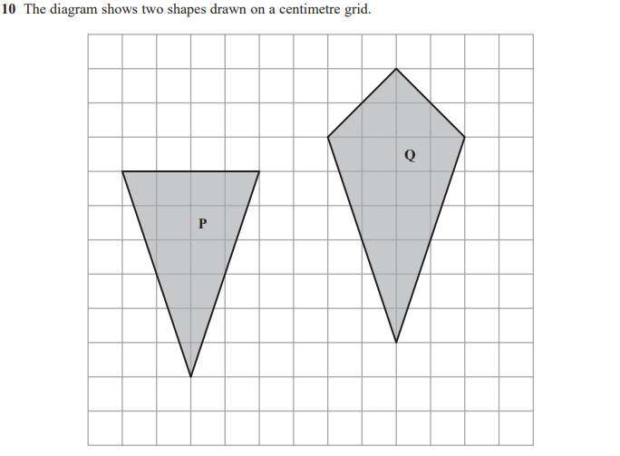
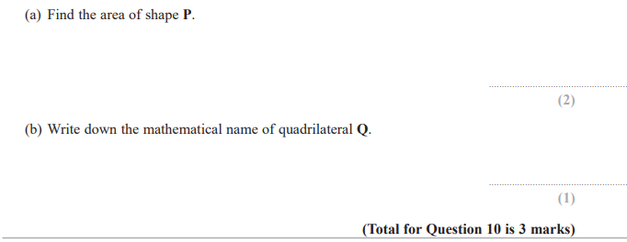

Pearson Edexcel – Specimen 2 - Paper 1 (Non-Calculator) Foundation Tier

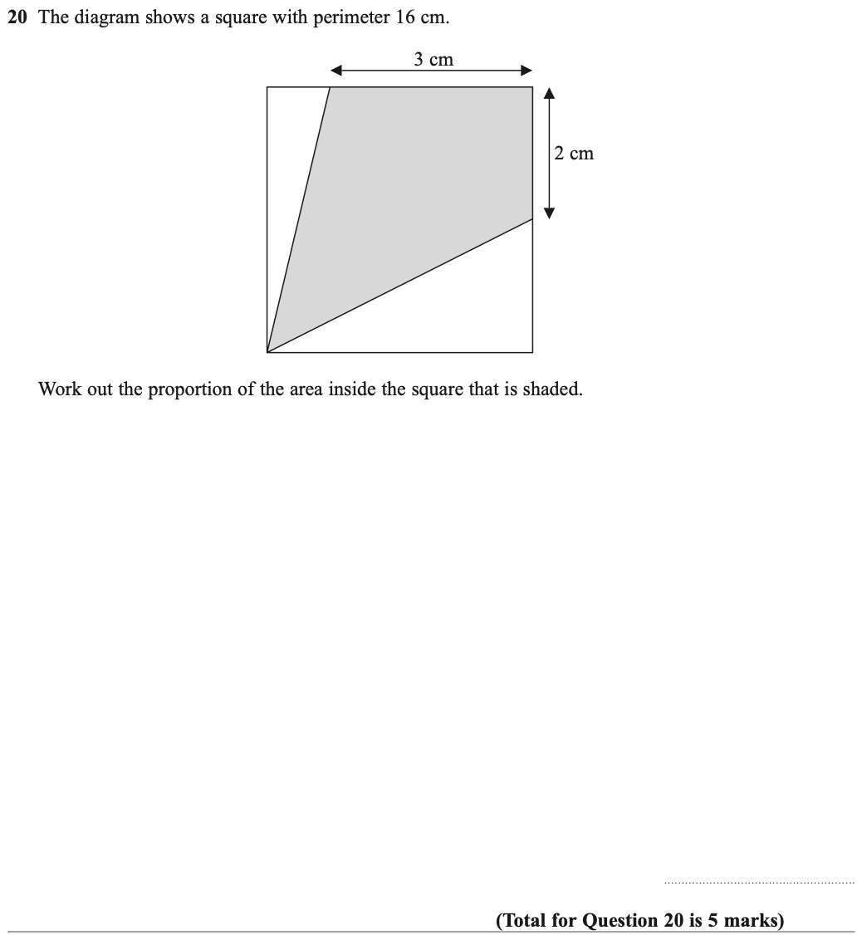

Pearson Edexcel – Specimen 2 - Paper 3 (Calculator) Foundation Tier

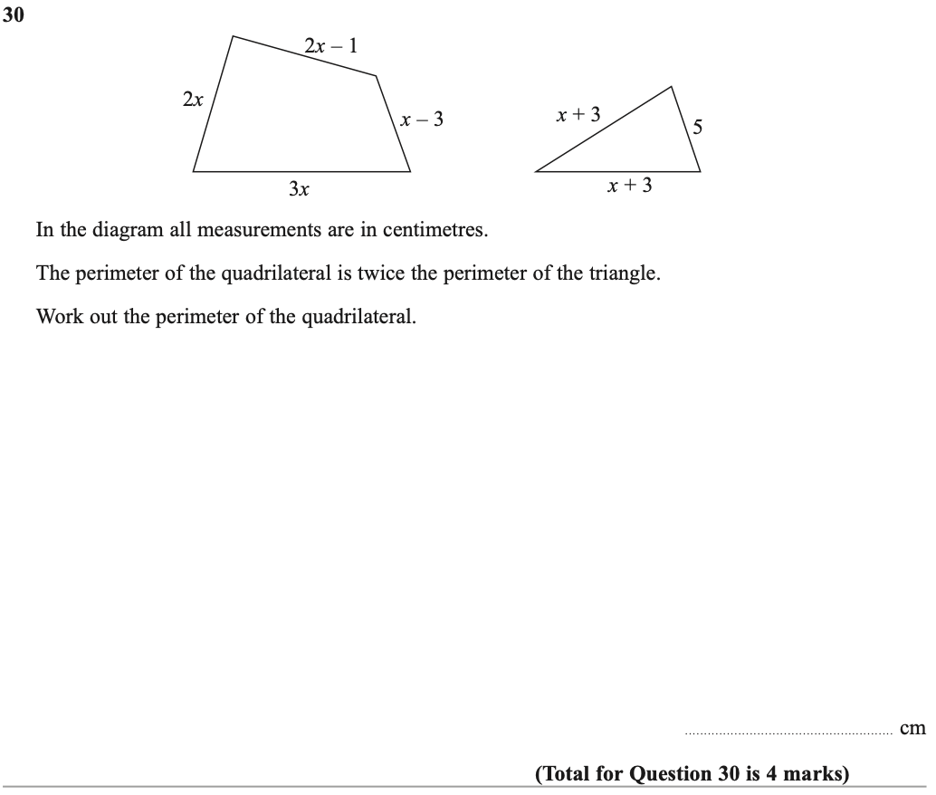

Pearson Edexcel – Specimen 1 - Paper 2 (Calculator) Foundation Tier

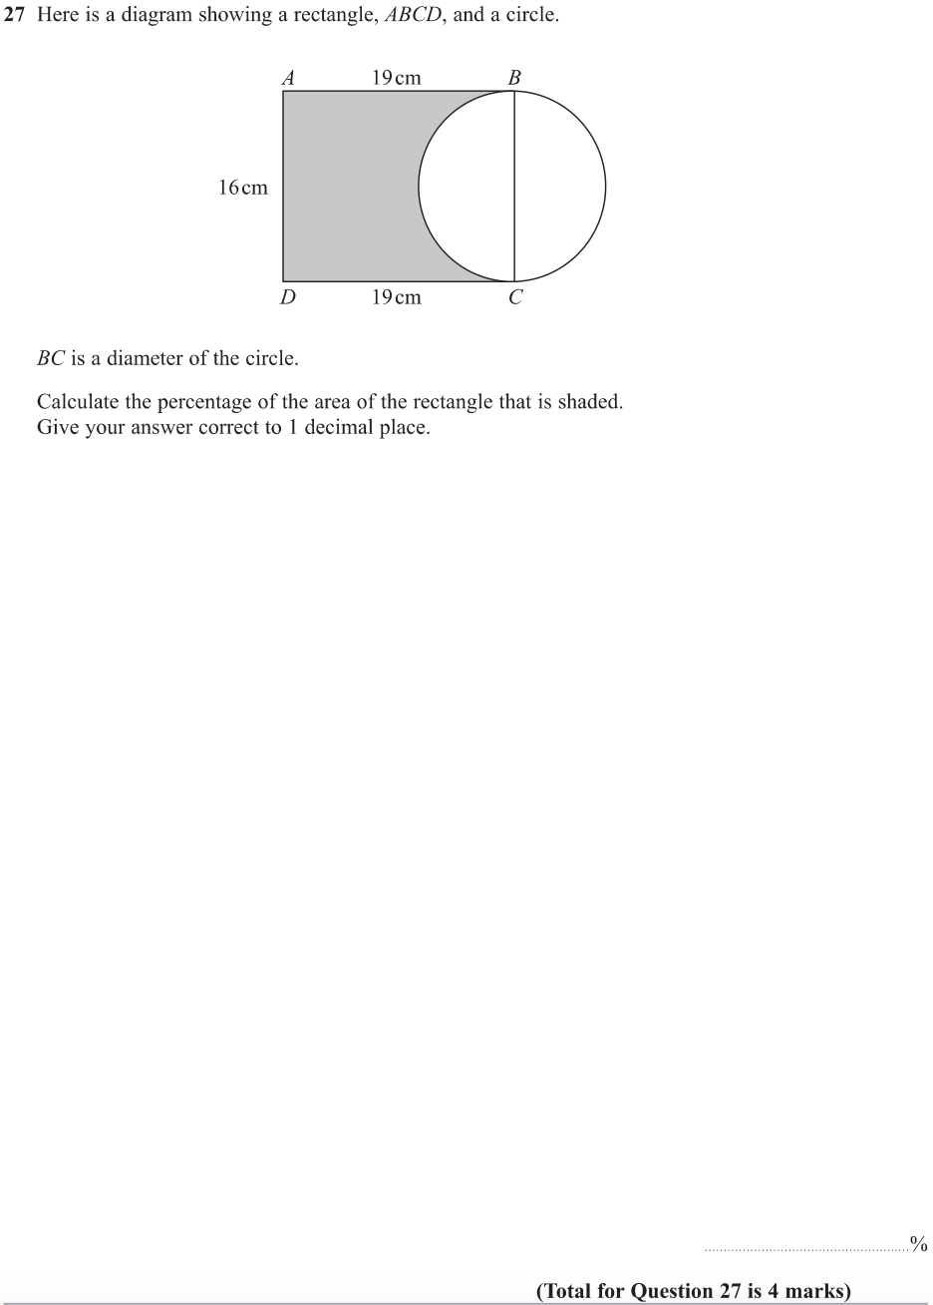

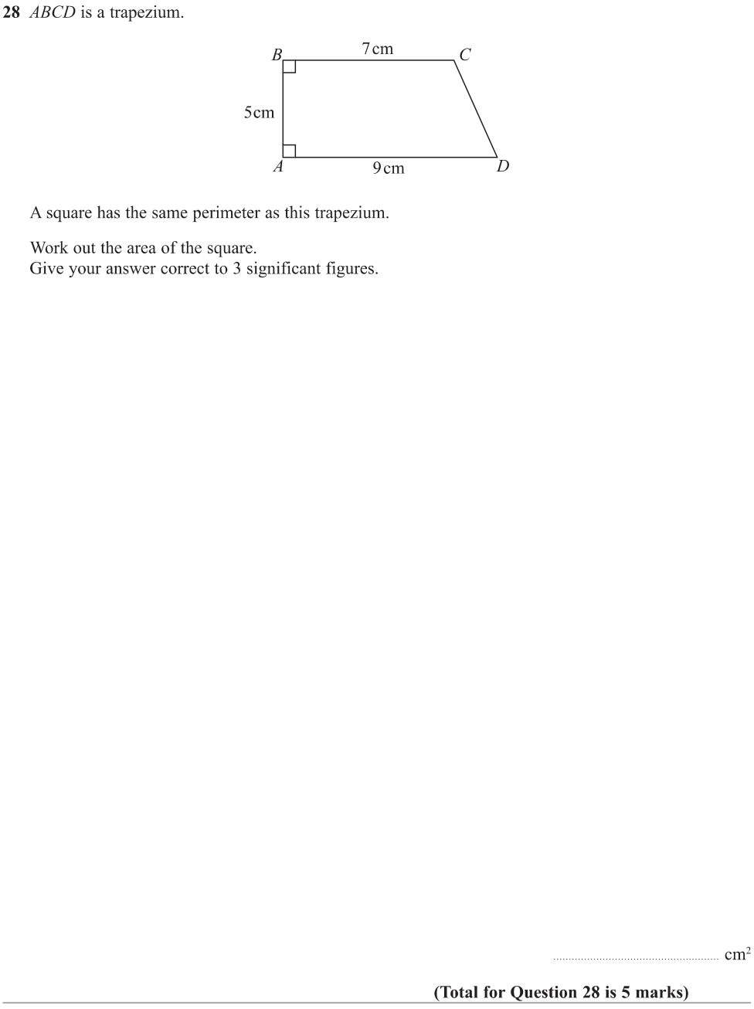
Pearson Edexcel – Specimen 1 - Paper 3 (Calculator) Foundation Tier

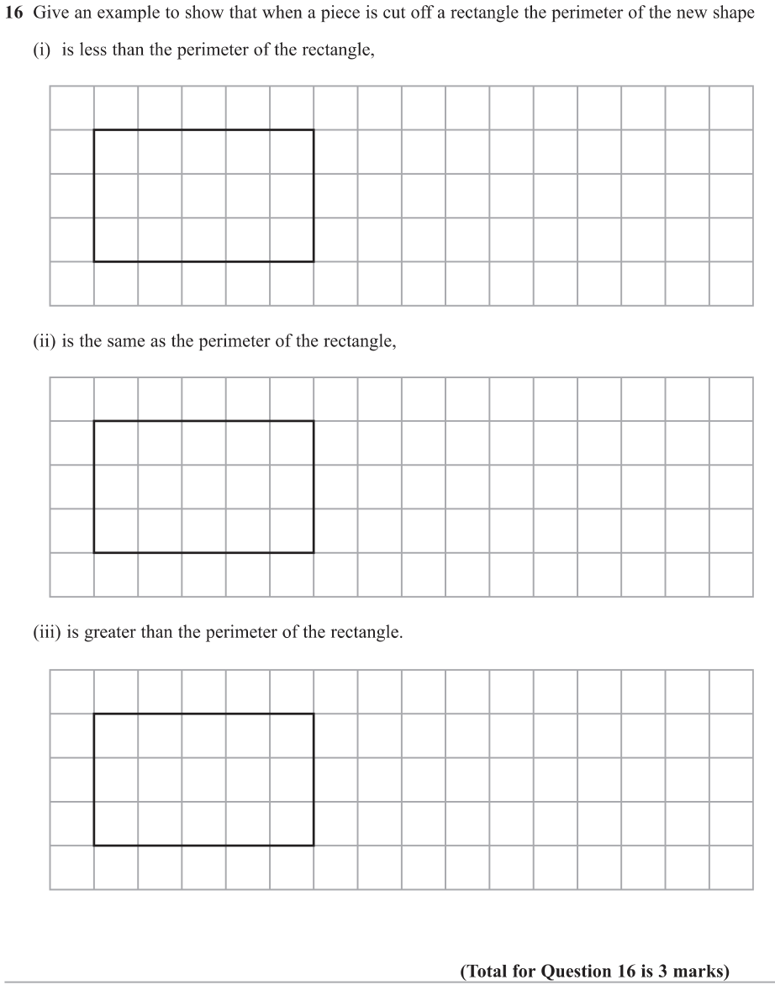
OCR Thursday 05 November 2020- Morning (Non-Calculator) Foundation Tier

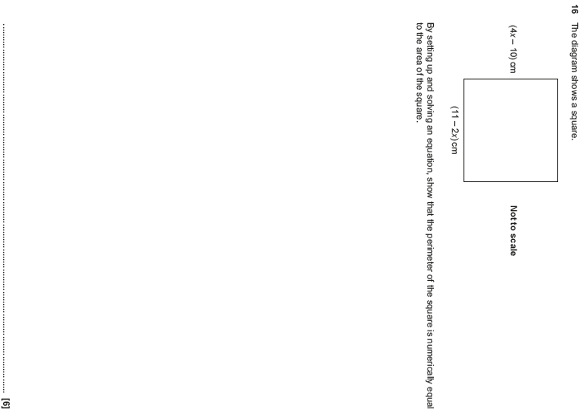

OCR November 09 November 2020- Morning (Calculator) Foundation Tier
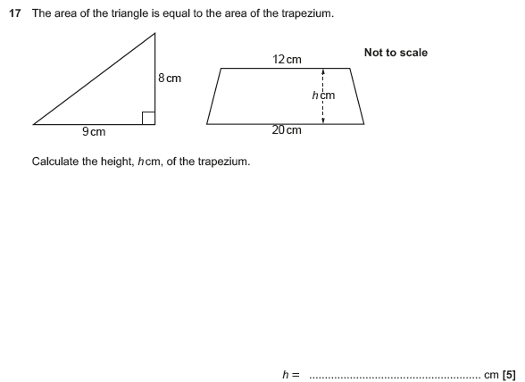

OCR Tuesday 5 November 2019 – Morning (Calculator) Foundation Tier
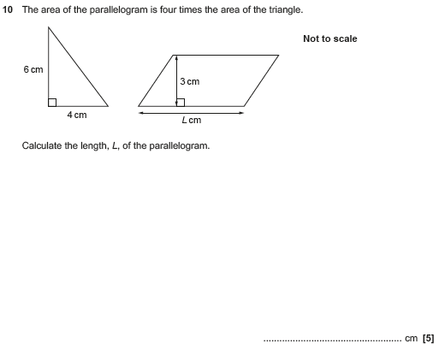

OCR Tuesday 5 November 2019 – Morning (Calculator) Foundation Tier
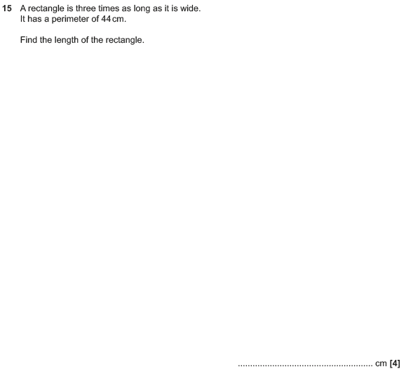

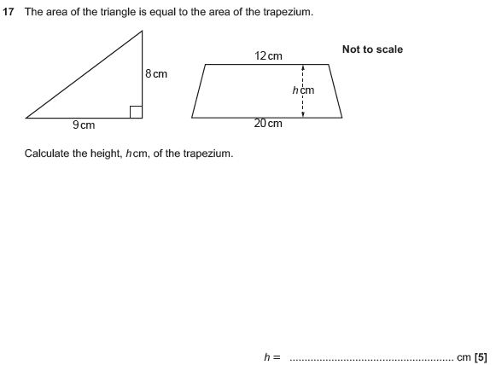

OCR Monday 11 November 2019 – Afternoon (Calculator) Foundation Tier
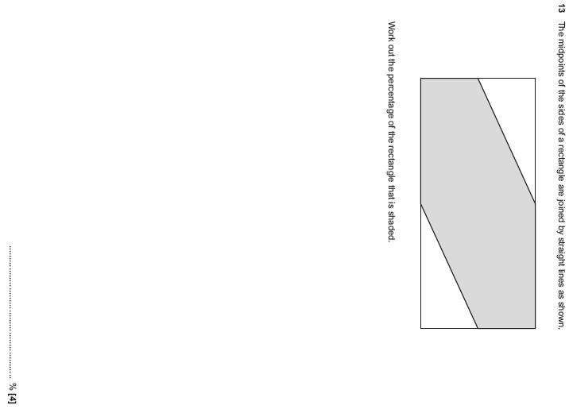

OCR Monday 11 November 2019 – Afternoon (Calculator) Foundation Tier
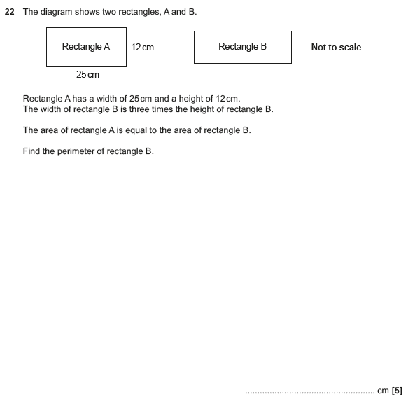

OCR Tuesday 11 June 2019 – Morning (Calculator) Foundation Tier
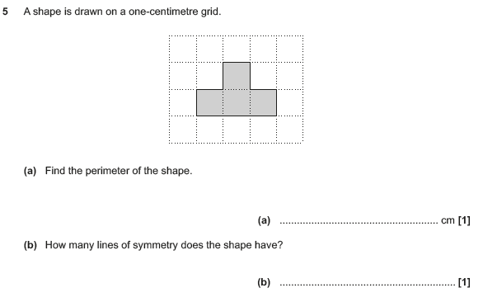

OCR Tuesday 6 November 2018 – Morning (Calculator) Foundation Tier
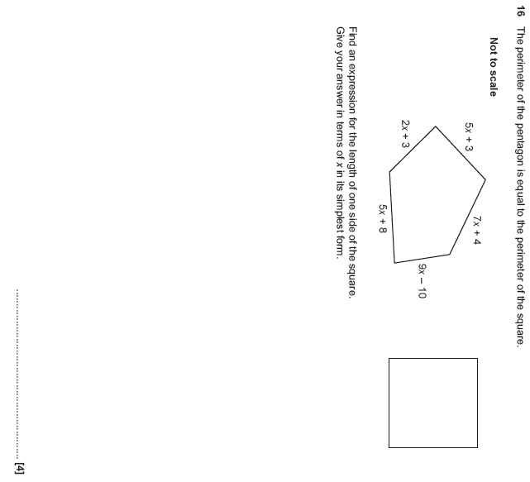

OCR Thursday 7 June 2018 – Morning (Non Calculator) Foundation Tier

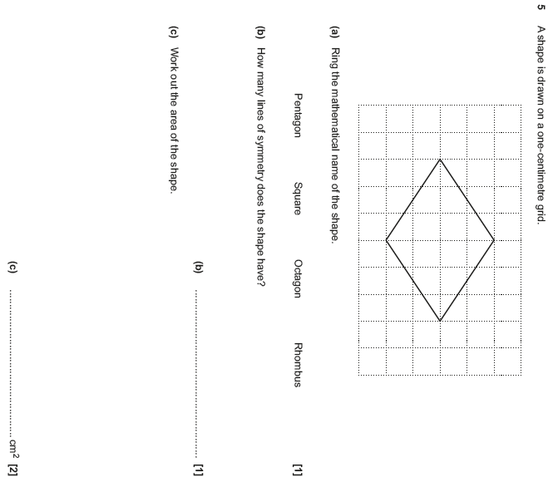

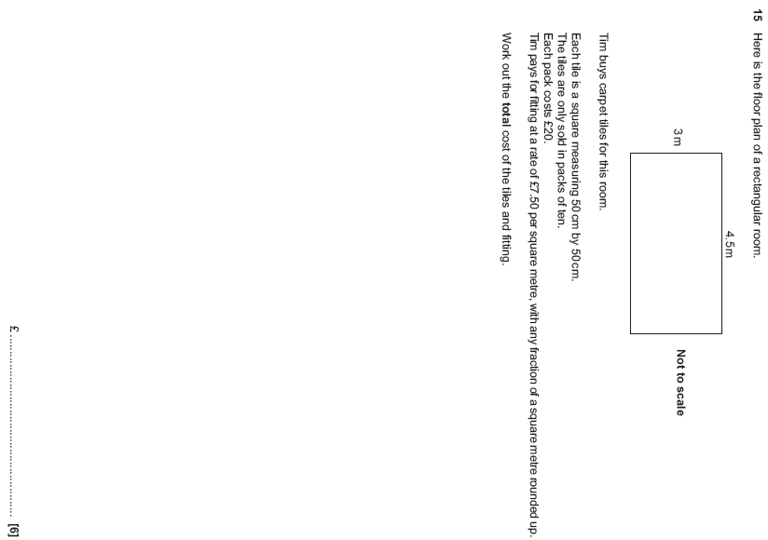

OCR Tuesday 12 June 2018– Morning (Calculator) Foundation Tier
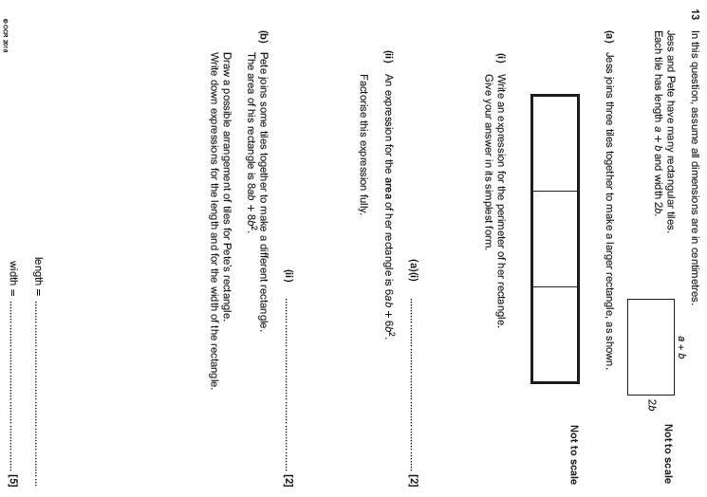

OCR Monday 6 November 2017– Morning (Calculator) Foundation Tier

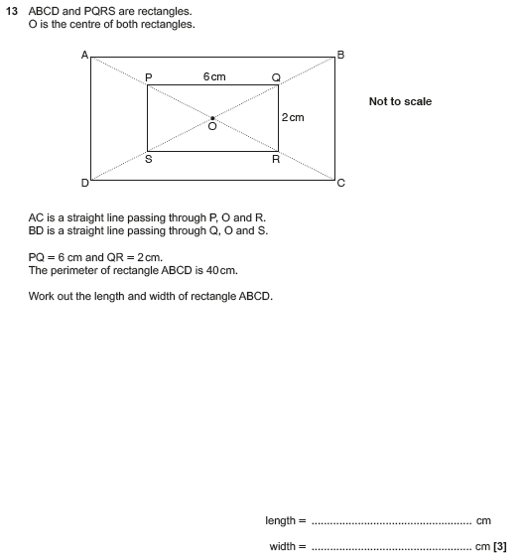

OCR Thursday 25 May 2017 – Morning (Calculator) Foundation Tier

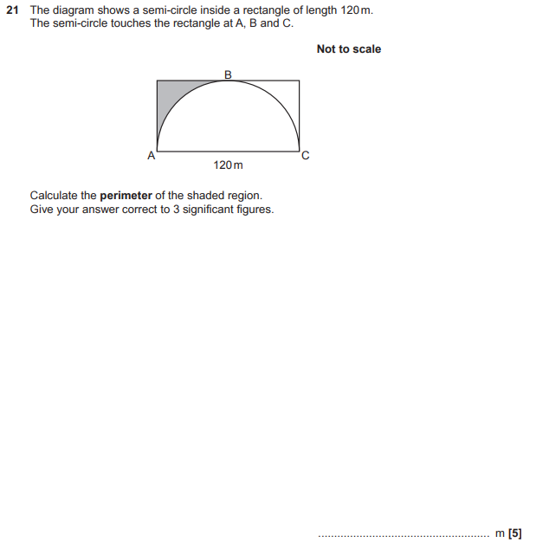

OCR Thursday 8 June 2017 – Morning (Non - Calculator) Foundation Tier

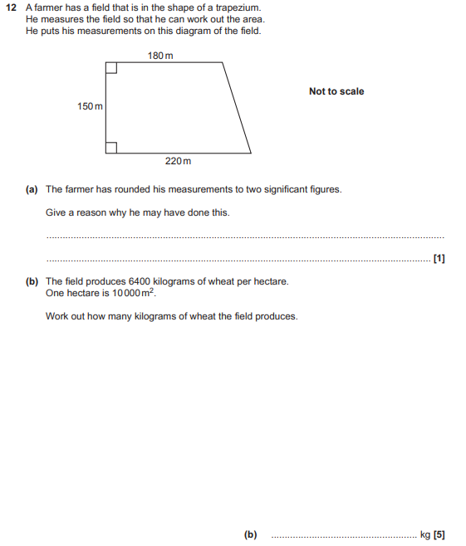

OCR Tuesday 13 June 2017 – Morning (Calculator) Foundation Tier

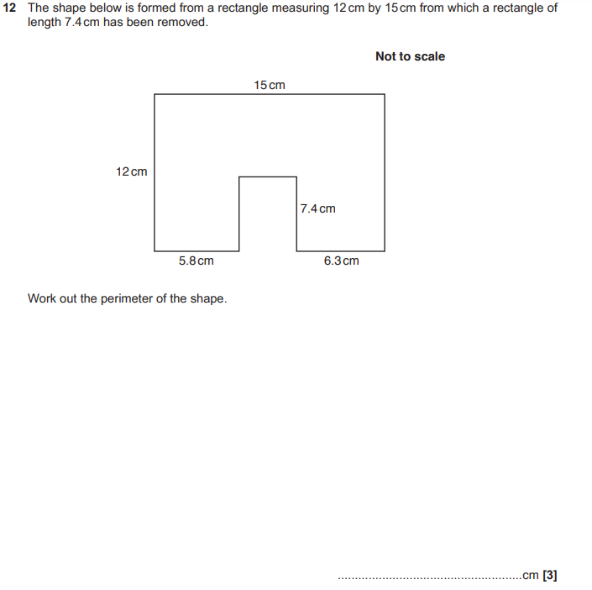

OCR Sample Question Paper 2 – Morning/Afternoon (Non - Calculator) Foundation Tier

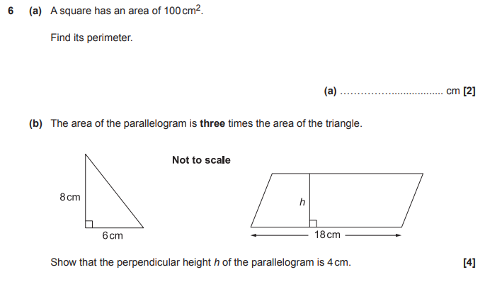

OCR Sample Question Paper 2 – Morning/Afternoon (Non - Calculator) Foundation Tier

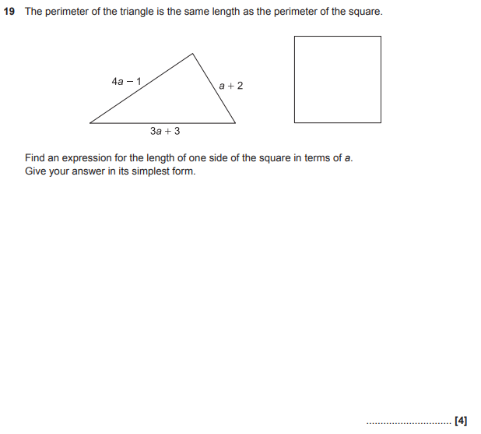

AQA Thursday 4 June 2020 – Morning (Calculator) Foundation Tier

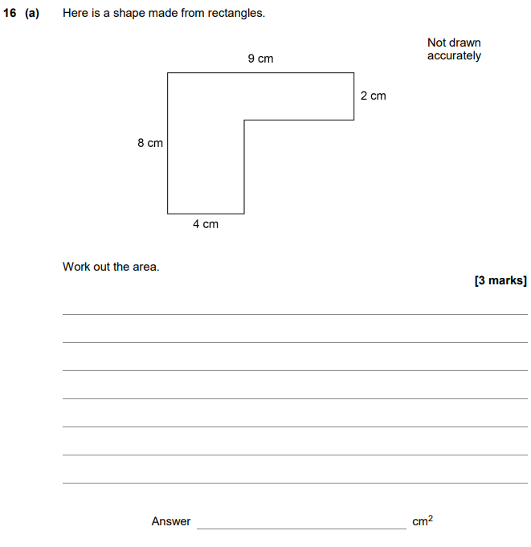

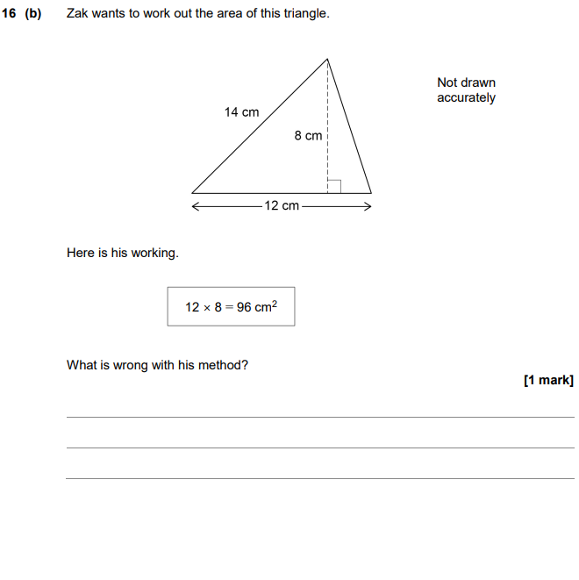

AQA Thursday 6 June 2019 – Morning (Calculator) Foundation Tier

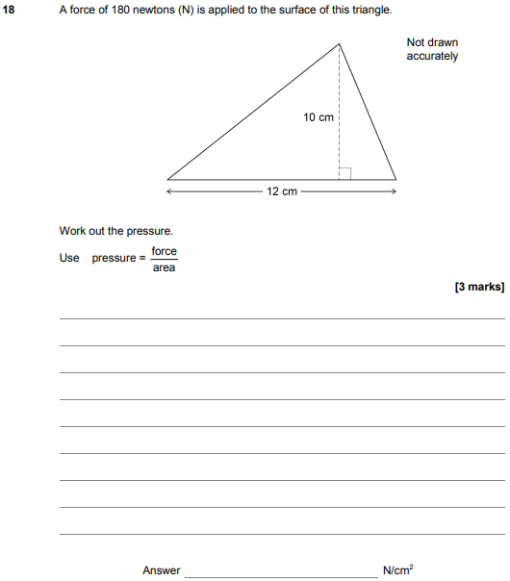

AQA Thursday 8 November 2018 – Morning (Calculator) Foundation Tier

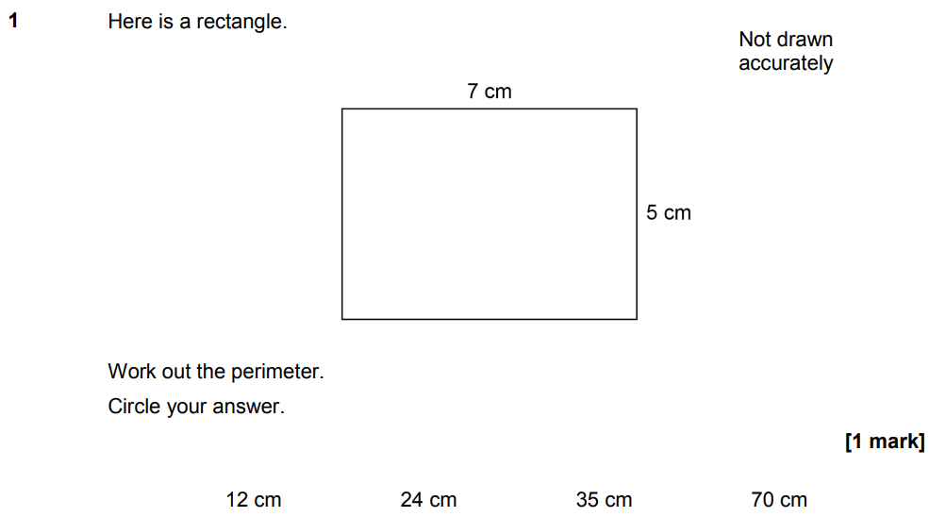

AQA Thursday 8 November 2018 – Morning (Calculator) Foundation Tier

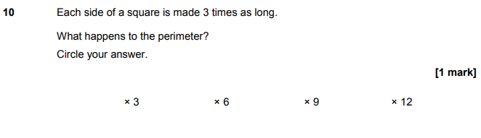

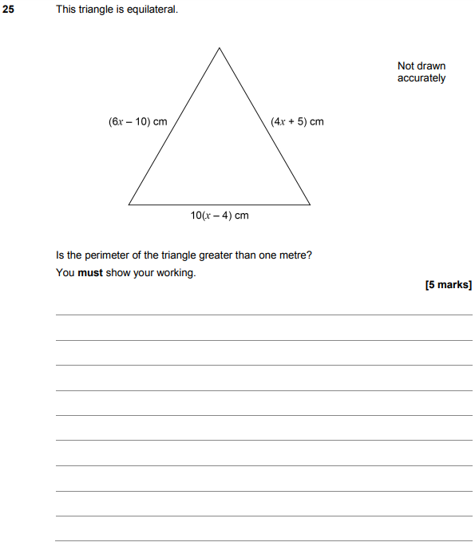

AQA Monday 12 November 2018 – Morning (Calculator) Foundation Tier

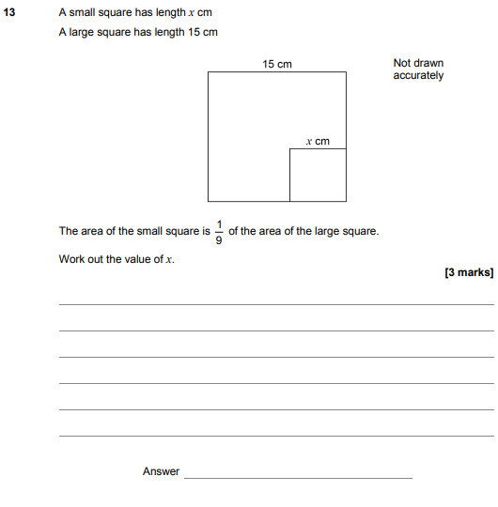

AQA Thursday 24 May 2018 – Morning (Non-Calculator) Foundation Tier

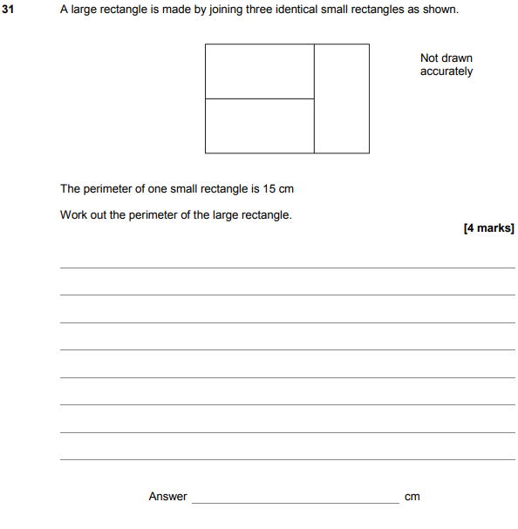

AQA Tuesday 12 June 2018 – Morning (Calculator) Foundation Tier

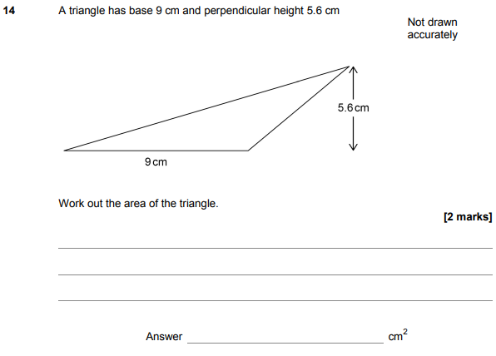

AQA Thursday 2 November 2017 – Morning (Non-Calculator) Foundation Tier

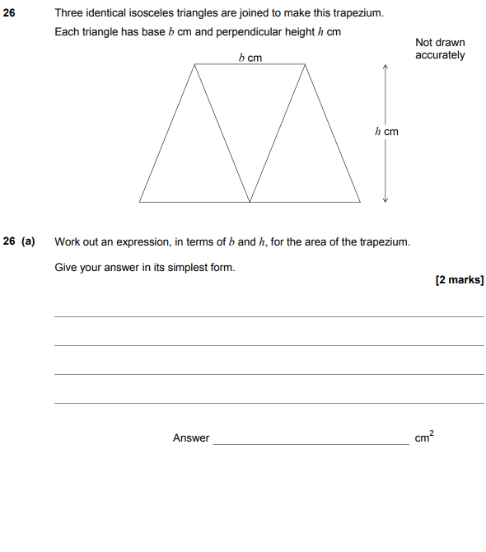

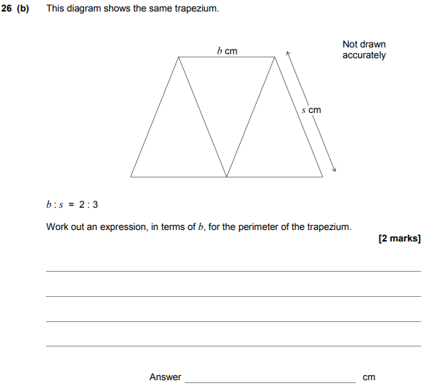

AQA Monday 6 November 2017 – Morning (Calculator) Foundation Tier

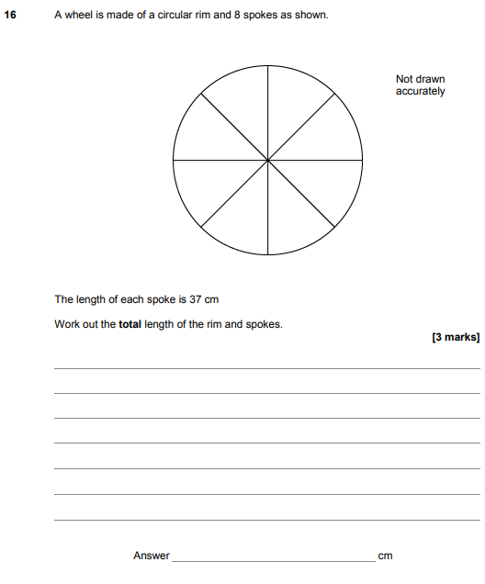

AQA Thursday 25 May 2017– Morning (Non-Calculator) Foundation Tier

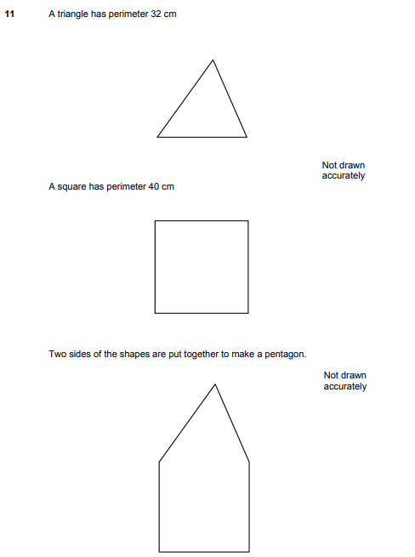
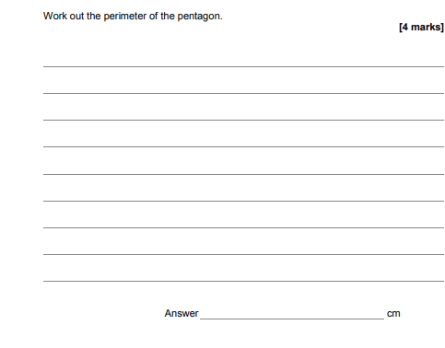

AQA Tuesday 13 June 2017 Morning– Morning (Calculator) Foundation Tier

